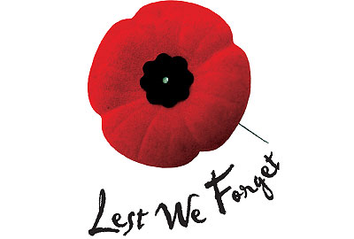

Remembrance Day Parade and Service
Sunday 14th November 2021
Parade from Warmley Community Centre at 10.20
Service at Warmley War Memorial Garden from 10.40

