Launch of new WESTLocal bus service
The parish councils of Bitton, Oldland, Pucklechurch and Siston came together to engage with their local communities to design an innovative route to create a WESTlocal bus service.
WESTlocal is a fund from the West of England Mayoral Combined Authority. Funding for the scheme comes from the Department for Transport’s Bus Service Improvement Plan.
Thanks to many local people who told the councils what kind of service they wanted and where they needed to get to, they have been able to design this route and bring it to life. Local knowledge and expertise of the parish councillors, officers and local community have helped to devise something completely new.
Mayor Dan Norris said, “This is what WESTlocal is all about – the community coming together to create bus services specially tailored for the needs of local people. I’m delighted that my Mayoral Combined Authority funding will benefit residents in such a positive way.”
The Parish councils now want to see communities embrace their WESTlocal to get to where they need to go, to consider leaving the car at home by choosing a green and environmentally friendly alternative. Its success will depend on local support.
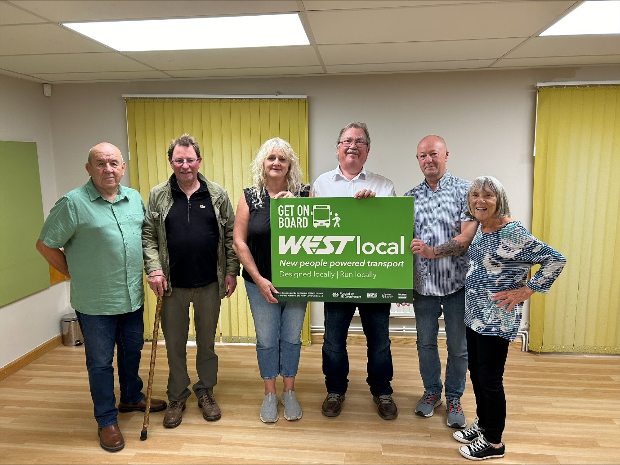
From left to right: Cllr Nick Watson representing Bitton Parish Council, Cllr Rick Dunning representing Pucklechurch Parish Council, Claire Dolman – Clerk to Oldland Parish Council, Cllr Steve Reade representing Siston Parish Council, Steve Skidmore – Parish Development Specialist for Oldland Parish Council and Cllr Carol Strange representing Oldland Parish Council.

